Advanced Signal Processing
  - Exam questions

Abstract
The oral exam lasts about 15 minutes per student, with 5 additional minutes for grading. Students randomly draw two topics from two different course areas (A: 1-4, B: 5-8, or C: 9-12) at the start of the exam and choose the order of discussion. They present their understanding of each topic, supported by a sheet of notes and using the blackboard for visuals, while examiners ask questions. The exam is graded on the 7-step scale and conducted in English or Danish by the course lecturers.

Contents
1. Wiener Filtering 2
2. Least-Mean-Squares Adaptive Filtering 3
3. RLS Adaptive Filtering 4
4. Multidimensional Fourier Transform 5
5. Signal Spaces 6
6. Detection theory 7
7. Minimum Mean Squared Error (MMSE) and Linear MMSE estimation 8
8. Kalman Filtering (scalar and vector versions) 9
9. One-step linear predictor 10
10. The Levinson-Durbin algorithm 11
11. AR-filter design by modelling 12
12. The Lattice FIR filter 13

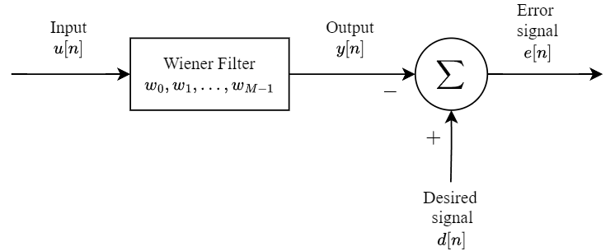
1. Wiener Filtering
Wiener filtering is a powerful linear technique used to minimize the mean squared error (MSE) between a desired signal d(n) and the filter output y(n). It is ideal for stationary signals, where signal statistics remain constant over time. The Wiener filter operates by finding an optimal set of weights w that minimizes the error e(n) between d(n) and y(n).
1. The filter output is computed as:
$$ex. 1 FIR filter with M weights \sum_{i=0}^{M-1}{w_{oi}r\left(i-k\right)=p\left(-k\right)}$$
$$y\left(n\right)=\sum_{k=0}^{∞}{w_{k}^{*}u\left(n-k\right)}$$
where u(n) represents the input signal and $w_{k}$​ are the filter weights.
The error signal is defined as:
Steepest descent
- Assumes knowledge of signal statistics (R,p).
- Optimal convergence to Wiener Solution as 𝑛 → ∞
- On Wiener-filtering (update rule):
$$w(n + 1) = w(n) + μ[p - Rw(n)]$$

$$e\left(n\right)=d\left(n\right)- y\left(n\right)$$
2. The optimization goal is to minimize the MSE:
$$J= E\left[{\left|e\left(n\right)\right|}^{2}\right]$$
3. To achieve this, the Wiener-Hopf equations are used:
where $R=E[uu^{H}]$ is the autocorrelation matrix of the input signal
$p=E[ud^{*}]$ is the cross-correlation vector between the input u(n) and the desired signal d(n)
$w_{o}={\left(w_{o0},w_{o1},…,w_{o,m-1}\right)}^{T}$(Optimal weights)
$Rw_{o}=p$, $w_{o}=R^{-1}p$ (matrix form)
The principle of orthogonality ensures that, at optimality, the error e(n) is orthogonal to all components of the input u(n). This property guarantees that the filter minimizes the MSE.
While the Wiener filter is effective, its implementation requires knowledge of R and p, which must be estimated in practice. Additionally, computing $R^{-1}$ can be computationally expensive for high-dimensional systems.
Applications: Wiener filters are widely used in noise cancellation, signal prediction, and system modeling.

Extra:
1. Wiener optimal solution
$$∇_{k} J= ∇_{k}E\left[e\left(n\right)e^{*}\left(n\right)\right]= -2E\left[u\left(n - k\right)e^{*}\left(n\right)\right] \\ ∇_{k} J= E\left[u\left(n - k\right)e_{o}^{*} \left(n\right)\right]= 0$$
Principle of orthogonality: when the filter operates optimally (i.e., J is minimum), $e_{o}\left(n\right)$ is orthogonal to each input sample $u\left(n – k\right)$ contributing to the estimation of the desired response.
2. Wiener-Hopf equations
From the Wiener optimal solution, we can expand by inserting $e_{o}^{*}$ :
$$E \left[u\left(n - k\right)\left(d^{*}\left(n\right)- \sum_{i=0}^{∞}{w_{oi}u^{*}\left(n - i\right)}\right)\right]=0$$
$$\sum_{i=0}^{∞}{w_{oi}E\left[u\left(n - k\right)u^{*}\left(n - k\right)\right]}=E\left[u\left(n - k\right)d^{*}\left(n\right)\right]$$
This leads to the Wiener-Hopf equations
$$\sum_{i=0}^{∞}{w_{oi}r\left(i-k\right)=p\left(-k\right)}, ex 1 ↑$$
With: $E\left[u\left(n – k\right)u^{*}\left(n – i\right)\right]= r\left(i – k\right)$
$$E\left[u\left(n - k\right)d^{*}\left(n\right)\right]= p\left(-k\right)$$

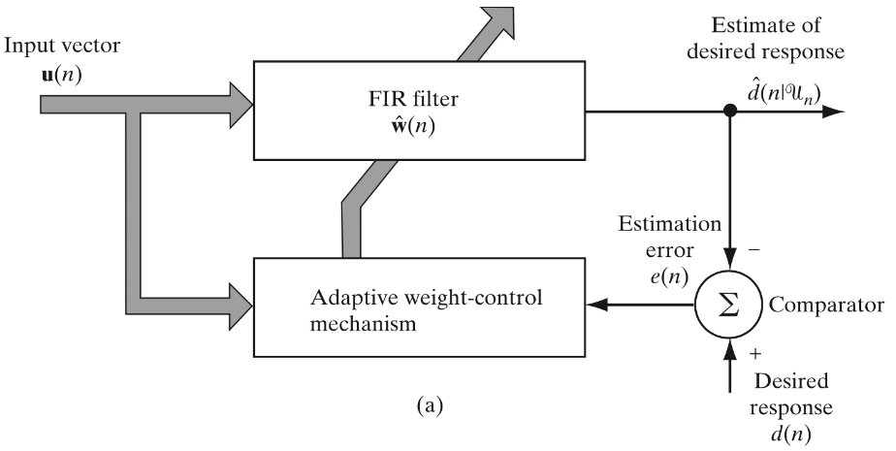
2. Least-Mean-Squares Adaptive Filtering
LMS adaptive filtering is a method to minimize the mean squared error between a desired signal and the filter output. It adjusts filter coefficients iteratively using stochastic gradient descent (SGD), making it simple and computationally efficient for real-time applications.

1. The goal of LMS filtering is to minimize the MSE cost function:
$d\left(n\right):$ Desired signal
$e\left(n\right):$ Error between the desired sig. and the filter output.
$$J= E\left[{\left|e\left(n\right)\right|}^{2}\right]=E\left[{\left|d\left(n\right)-w^{H}\left(n\right)u\left(n\right)\right|}^{2}\right]$$
2. Approximation Using Instantaneous Error:
Instead of using the expectation operator, LMS minimizes the instantaneous squared error:
$$J_{s}\left(n\right)= {\left|e\left(n\right)\right|}^{2}=e\left(n\right)e^{*}\left(n\right)$$
3. Gradient Computation:
The gradient of the cost function $J_{s}\left(n\right)$ with respect to the filter weights $w\left(n\right)$ is:
$$∇J_{s}\left(n\right)=\frac{∂J_{s}\left(n\right)}{∂w_{k}^{*}\left(n\right)}=-2u\left(n - k\right)e^{*}\left(n\right)$$
4. Weight Update (Minimization Step):
To minimize $J_{s}\left(n\right)$, the filter weights are updated in the direction of the negative gradient:
$${\hat{w}}_{k}\left(n + 1\right)= {\hat{w}}_{k}\left(n\right)-\frac{1}{2}μ∇J_{s,k}\left(n\right)$$
Substituting $∇J_{s,k}\left(n\right)$, the update rule becomes:
$${\hat{w}}_{k}\left(n + 1\right)={\hat{w}}_{k}\left(n\right)+μ⋅u\left(n - k\right)e^{*}\left(n\right)$$
5. Stability Criterion:
As for steepest descent, convergence/stability of LMS is guaranteed when: $0<μ<\frac{2}{λ_{max}}$. Where $λ_{max}$ is the largest eigenvalue of the input signal’s autocorrelation matrix. In practice, μ has to be sufficiently small for a robust behavior NOTICE: Instantaneous estimates for 𝐑 and 𝐩 are included by the feedback and averaged over time.
Normalized LMS: LMS can suffer from unstable updates when the input signal has high power. NLMS resolves this by normalizing the step size with the signal power i.e. ${\left\|u\left(n\right)\right\|}^{2}$: ¨
$$\hat{w} \left(n + 1\right)= \hat{w} \left(n\right)+\frac{μ}{δ+{\left\|u\left(n\right)\right\|}^{2}}⋅u\left(n - k\right)e^{*}\left(n\right)$$
Where the 𝛿 is included for numerical stability. NLMS reduces the risk of large updates and ensures faster convergence.

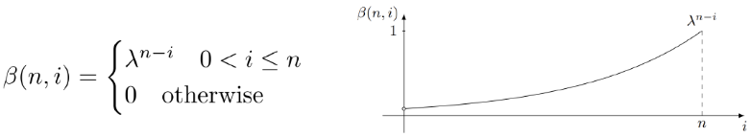
3. RLS Adaptive Filtering
Exponential Window
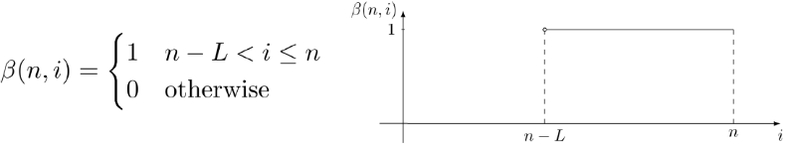
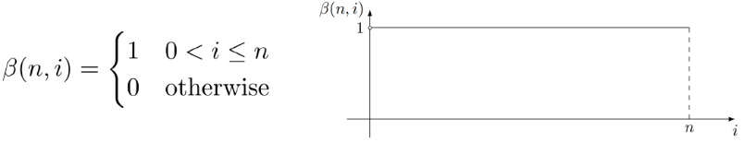
The Recursive Least-Squares (RLS) algorithm minimizes the weighted least squares error between a desired signal d(n) and the filter output y(n). It uses past data with exponentially decreasing weights, enabling fast convergence and adaptability to non-stationary signals.
Sliding Window
Growing Window
1. Minimize Cost Function: The RLS algorithm minimizes a least-squares cost function $J_{2}\left(w\right)$, which sums the squared errors over a data segment:
$i_{1}$ and $i_{2}$ : segment’s length
$w:$ filter weights.
$$J_{2}\left(w\right)=\sum_{i=i_{1}}^{i_{2}}{e^{2}\left[i\right]}=\sum_{i=i_{1}}^{i_{2}}{{\left(d\left[i\right]-y\left[i\right]\right)}^{2}}$$
2. Weighted Cost Function: To prioritize recent data, the RLS algorithm uses a weighted cost function with a weighting factor $(β\left[n,i\right])$:
$λ$: forgetting factor. Assigning less weight to older data $↓$
$$J_{β}\left(\hat{w}\left[n\right]\right)=\sum_{i=1}^{n}{β\left[n,i\right]e^{2}\left[i\right]} \\ =\sum_{i=1}^{n}{β\left[n,i\right]{\left(d\left[i\right]-{\hat{w}}^{T}\left[n\right]u\left[i\right]\right)}^{2}}$$
3. Exponential Weighting: The weighting function $(β\left[n,i\right])$ can take the form of the exponential function:
$$β\left[n,i\right]=λ^{n-i}, 0<λ≤1, i=1,2,…,n$$
4. Regularization Term: To prevent noise from affecting early updates, a regularization term $δ$ is added to the cost function:
$$J_{β}\left(\hat{w}\left[n\right]\right)=\sum_{i=1}^{n}{λ^{n-i}e^{2}\left[i\right]}+δλ^{n}|\hat{w}\left[n\right]|^{2}$$
5. Gradient: The gradient of this cost function with respect to the filter weights is calculated and set to zero, resulting in the following system of equations:
$$∇J_{β}\left(\hat{w}\left[n\right]\right)=0 \\ \sum_{i=1}^{n}{λ^{n-i}u\left[i\right]u^{T}\left[i\right]\hat{w}\left[n\right]}+δλ^{n}\hat{w}\left[n\right]=\sum_{i=1}^{n}{λ^{n-i}u\left[i\right]d\left[i\right]} \\ Φ\left[n\right]\hat{w}\left[n\right]=z\left[n\right]$$
$Φ\left[n\right]$ is an $M × M$ time-average auto-correlation matrix of the filter input. $z\left[n\right]$ is an $M × 1$ time−average cross−correlation vector.
To solve the weighted normal equations:
$$Φ\left[n\right]\hat{w}\left[n\right]=z\left[n\right]$$
One must solve:
$$\hat{w}\left[n\right]=Φ^{-1}\left[n\right]z\left[n\right]$$
6. Correlation Matrix: Using exponential weight, the recursive computation of the correlation matrix $Φ\left[n\right]$ is:
$$Φ\left[n\right]=λΦ\left[n-1\right]+u\left[n\right]u^{T}\left[n\right]$$
This equation states that the present value of the correlation matrix Φ[n] is computed by the old matrix Φ[n − 1] and the outer product of the newly arrived input sequence. The same approach for recursive computation of the vector z[n] leads to:
$$z\left[n\right]= λz\left[n-1\right]+u\left[n\right]d\left[n\right]$$
8. Matrix Inversion: After calculating Φ[n] and z[n], the filter weights are obtained by inverting the matrix Φ[n] and solving the system. However, this can be computationally expensive, especially for large filter lengths. To address this, the Matrix Inversion Lemma is used giving us:
$$Φ^{-1}\left[n\right]=λ^{-1}Φ^{-1}\left[n-1\right]-λ^{-1}k\left[n\right]u^{T}\left[n\right]Φ^{-1}\left[n-1\right]$$
9. Weight Update: The filter weight update is given by: $\hat{w}\left[n\right]=Φ^{-1}\left[n\right]z\left[n\right]=\hat{w}\left[n-1\right]+k\left[n\right]ξ\left[n\right]$
$k\left[n\right]$: Gain vector, determines the weight adjustment
$ξ\left[n\right]$: Priori estimation error
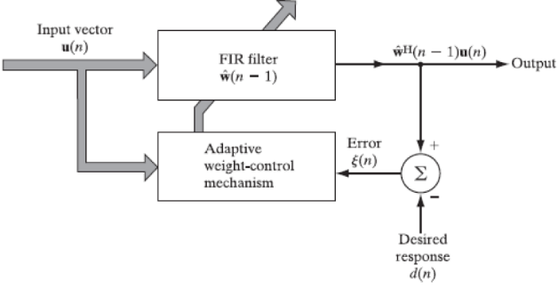

4. Multidimensional Fourier Transform

The multidimensional Fourier transform generalizes the Fourier transform to signals defined in multiple dimensions. It is a critical tool for analyzing spatial and temporal signals in fields like imaging, radar, telescopes and medical diagnostics.
1. Fourier Series
Assume a function $f$ defined over a finite interval T:
$f\left(t\right)=\sum_{k=-∞}^{∞}{a_{k}e^{i2πk\frac{t}{T}}}$, $a_{k}=\frac{1}{T}\int_{T}{f\left(t\right)e^{-i2πk\frac{t}{T}}} dt$
Fourier Transform (Analysis): Given a function $f∈L^{1}\left(R\right)$, the Fourier transform $F$ is defined as:
$F\left(ω\right)=F\{f\left(t\right)\}=\int_{R}{f\left(t\right)e^{-i2πkt}} dt$
Inverse Fourier Transform (Synthesis): Given a function $(F∈L^{1}\left(R\right))$, the inverse Fourier transform $(F^{-1})$ is defined as:
$\hat{f}\left(t\right)=F^{-1}\{F\left(k\right)\}=\int_{R}{F\left(k\right)e^{i2πkt}} dk$
Any periodic function can be represented exactly using Fourier series.
General Properties of Fourier Transform
Spectrum: $S_{f}\left(k\right)={\left|F\left(k\right)\right|}^{2}, F\left(k\right)=F\{f\left(t\right)\}$
Bandwidth: $F\left(k\right)=0 ∀k∉B$
Duality Property: The Fourier transforms are related by the following relations:
$\left.\begin{matrix}F\{f\}=F^{-1}\{f^{-}\} \\ F\{F\{f\}\}=f^{-}\end{matrix}\right\}, \text{where }f^{-}\left(x\right)=f\left(-x\right)$
Nyquist Sampling Theorem: Let f be a signal with band-limit B. Then, we can reconstruct f exactly as long as the sampling frequency is greater than 2B.

Parity of a Function:
$f\left(x\right)$ is even if $f\left(-x\right)=f\left(x\right).$
$f\left(x\right)$ is odd if $f\left(-x\right)=-f\left(x\right).$

Theorem | $$f\left(x\right)$$ | $$F\left(k\right)$$
Similarity | $$f(ax)$$ | $$\frac{1}{\left|a\right|}F\left(\frac{k}{a}\right)$$
Addition | $$f\left(x\right)+g(x)$$ | $$F\left(k\right)+G(k)$$
Homogeneity | $$af(x)$$ | $$aF(k)$$
Time/phase shift | $$f(x-a)$$ | $$e^{i2πak}F(k)$$
Convolution | $$f\left(x\right)*g(x)$$ | $$F\left(x\right)*G(x)$$
Derivative | $$f'(x)$$ | $$i2πk⋅F(k)$$

Fourier Transform follows the properties:

s
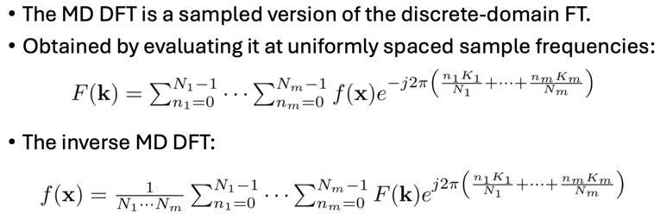
Rayleigh’s Theorem (Energy): Parseval’s Theorem (Power):
$\int_{R^{n}}{{\left|f\left(x\right)\right|}^{2}dx}=\int_{R^{n}}{{\left|F\left(ω\right)\right|}^{2} dω}$ $\int_{R^{n}}{f\left(x\right)g^{*}(x)dx}=\int{F\left(ω\right)G^{*}\left(ω\right)dω}$

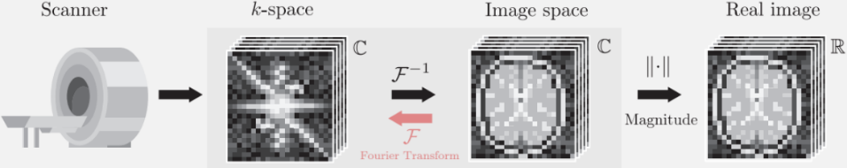
2. Multidimensional Fourier Transform
For a signal $f\left(x\right)$ with $x={\left[x_{1},x_{2},…,x_{N}\right]}^{T}∈R^{n}$.
The Fourier transform is:
$F\left(ω\right)=F\{f\left(x\right)\} =\int_{R^{n}}{f\left(x\right)e^{-i2πx^{T}ω} dx}$
The inverse Fourier transform reconstructs the signal:
$f\left(x\right)=\int_{R^{n}}{F\left(ω\right)e^{i2πx^{T}ω} dω}$
Note that the exponential function $(e^{i2πx^{T}ω})$ is determined by the product of the vectors 𝐱 and $ω$ where $ω={\left[ω_{1},…,ω_{n}\right]}^{T}$is the multidimensional frequency vector: $x⋅ω=x_{1}ω_{1}+…+x_{n}ω_{n}$
Why have a vector of frequencies? For a fixed $ω$, the exponential function represents a family of parallel lines in the $\left(x_{1},x_{2}\right)$-plane (or in the spatial domain), normal to $ω$, with spacing: $\text{distance}=\frac{1}{\sqrt{ω_{1}^{2}+ω_{2}^{2}}}= \frac{1}{\left\|ω\right\|}$ Periodicity: We may now parametrize x using the normalized frequency vector. Give the starting point $a= {\left[a_{1}, a_{2}\right]}^{T}$ we obtain that: $x\left(t\right)=a+t\frac{ω}{\left\|ω\right\|}$
Therefore, the complex exponential function adopts the following form: $e^{±i2πx^{T}\left(t\right)ω}=e^{±i2πa^{T}ω}⋅e^{±i2πt\left\|ω\right\|}$
The first term is constant, not depending on t. The second term is periodic with period 1/||ω||. Therefore, although the frequency now is a vector $ω$ we can keep most of the terminology for the one-dimensional case.
Separability: If a multivariable function can be written as a product of single-value:
$f\left(x_{1}, x_{2}, … , x_{n}\right)=f_{1}\left(x_{1}\right)f_{2}\left(x_{2}\right)⋯f_{n}\left(x_{n}\right)$
$F\left\{f\left(x_{1}, x_{2}, … , x_{n}\right)\right\}=F\left\{f_{1}\left(x_{1}\right)\right\}F\left\{f_{2}\left(x_{2}\right)\right\}⋯F\left\{f_{n}\left(x_{n}\right)\right\}$

Theorem | $$f\left(x\right)$$ | $$F\left(ω\right)$$
Similarity | $f\left(ax\right)$ with $a∈R^{n}$ | $$\frac{1}{\left|a_{1}a_{2}⋯a_{n}\right|}F\left(\frac{ω_{1}}{a}, \frac{ω_{1}}{a},⋯,\frac{ω_{n}}{a}\right)$$
Addition | $$f\left(x\right)+g(x)$$ | $$F\left(ω\right)+G(ω)$$
Shift | $$f(x-a)$$ | $$e^{i2πaω}F(ω)$$
Conv. | $$f\left(x\right)*g(x)$$ | $$F\left(ω\right)G(ω)$$
Deriv. | $$\frac{∂}{∂x_{i}}f(x)$$ | $$i2πω_{i}⋅F(ω)$$

General Stretch Theorem: For any linear transformation, A, of the input data, the Fourier transform is: $F\{f\left(Ax\right)\}=\frac{1}{\left|\det{(A)}\right|} F(A^{-T}ω)$ .

Special case – Rotations: The rotation matrix, R, has the property that $R=R^{T}$ and det(R) = 1, i.e., A rotation matrix R in the spatial domain results in the same rotation in the frequency domain: $F\{f\left(Rx\right)\}=F\left(Rω\right)$.

5. Signal Spaces
A signal space is an inner product space where all elements have finite norm. Each element is called a signal.
Examples of signal spaces:
Finite length real-values discrete time signals:
$$x={\left[x_{1},x_{2}…,x_{N}\right]}^{T},y={\left[y_{1},y_{2},…,y_{N}\right]}^{T}$$
$$Inner Product Space: 〈x, y〉=\sum_{n=1}^{N}{x_{n}y_{n}}=x^{T}y=y^{T}x \left(matrix form\right) \\ Energy of x: {\left\|x\right\|}^{2}=〈x,x〉=\sum_{n}{x_{n}^{2}}$$
If x and y are complex-valued:
$$〈x, y〉=\sum_{n=1}^{N}{x_{n}y_{n}^{*}}=x^{H}y (matrix form)$$
$${\left\|x\right\|}^{2}=\sum_{n}{{\left|x_{n}\right|}^{2}}$$
where $x^{H}$ is the Hermitian transpose of x (i.e., transpose and complex conjugate *).
Inner Product Space: A signal space is often equipped with an inner product to measure similarity or orthogonality between signals.
Norm: The norm (magnitude) of a signal is given by $\left\|x\right\|=\sqrt{〈x,x〉}$.
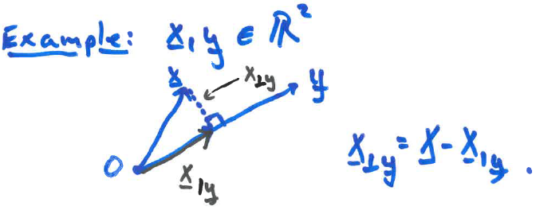
Orthogonality: Two signals x and y are orthogonal if: $〈x,y〉=0$. Orthogonal signals carry independent information, which is key in applications like multiplexing.
Projection of signal x onto signal y: $x_{,y}=\frac{〈x, y〉}{{\left\|y\right\|}^{2}}y$ , if ${\left\|y\right\|}^{2}=1,$ then $x_{,y}=〈x, y〉y$

Applications and Examples
- Fourier Analysis:
  - Sinusoidal basis functions $ϕ_{k}(t)=e^{i2πkt}$ decompose signals into their frequency components.
- Orthogonal Projections:
  - Used in least squares for minimizing the error between a signal and its approximation.
- Signal Approximation:
  - Signals can be approximated by projecting onto a subspace spanned by orthogonal basis functions.

6. Detection theory

How do we make a decision?
- Daily life no specific ruleset,
- Sometimes a particular rule or method
- Formulate decision rule
- Optimality criterion

Engineers:
The goal of detection theory is to select one of 𝐾 mutually exclusive hypotheses in the set $H = \left\{h_{0}, . . , h_{k-1}\right\}$, based on some observations, $x = \left[x_{1}, … , x_{n}\right]ᵀ$. This data vector is deterministic but, we model it as a realization of a random vector, denoted with pdf $f_{X}$.
Probability Model for Decision Problems: To do this, a decision rule is used, which is a function $\hat{H}\left(x\right),$ that assigns a hypothesis for each possible observation i.e.
$$\hat{H} : \text{range}\left(X\right)→H.$$
We mark the output of a decision rule with a hat to indicate that the decision $\hat{H}\left(x\right)$ is not necessarily equal to the true hypothesis H. We may have some prior knowledge about the likeliness of a hypothesis being true: $P_{k}$ is the prior probability of the hypothesis. The prior probabilities sum to one: $P_{0}+…P_{K+1}=1$. After making the observations, our view of the probability of a given hypothesis being true changes. Now we say
$P\left(''\hat{H}\text{ is true given }x^{''}\right)=P\left(H=h_{k} | x\right)$,
Also known as the a posteriori probability of $h_{k}$ being true. Where: $f_{X|H}\left(x | h_{k}\right)$ is the likelihood for $h_{k}$ and is a conditional pdf of $X.X$ depends on which of the hypotheses are true, thus it's the conditional pdf of $X$ under hypothesis $h_{k}$ (likelihood for $h_{k}) , f_{X|H}(x|h_{k}).$
Bayes' theorem can expand the a posteriori probability and include the prior and likelihood:
$$P\left(H=h_{k} | x\right)=\frac{ f_{X|H}(x|h_{k})P_{k}}{f_{X}\left(x\right)}$$
The denominator will be disregarded since it’s the same regardless of $h_{k}$ and will not enter the decision rules when derived. If we consider the decision rule evaluated at the random data, $X,$ then the decision $\hat{H}\left(X\right)$ is a random variable.
Maximum A Posteriori Probability (MAP) Decision Rule: The MAP decision rule picks the hypothesis which has the highest probability of being correct. That is:
$${\hat{H}}_{MAP}\left(x\right)=\arg{\max_{h_{k}∈H}{f_{X|H}\left(x | h_{k}\right)P_{k}}}$$
The prior probability affects the probability significantly. $P_{k}=0$ means the hypothesis will never be selected, and the opposite if $P_{k}=1.$ Furthermore, the more probable a hypothesis is (before we observe the data), the more convincing the data needs to be in order for us to change our minds.
Decision Regions: The regions of the x-axis for which the rule will select a respective hypothesis.
Maximum Likelihood (ML) Decision Rule: In cases where no prior probability is available or undesirable to use, one can instead set all prior probabilities equal. This results in the ML-decision rule:
$${\hat{H}}_{ML}\left(x\right)=\arg{\max_{h_{k}∈H}{f_{X|H}\left(x | h_{k}\right)}}$$
Bayes' Decision Rule: Instead of maximizing a probability, Bayes' decision rule minimizes a cost/risk of choosing a particular hypothesis. For this, a cost $C_{kk}$ is assigned for if $h_{k}$ is decided and $h_{k}$ is true. Diagonal cost should be low, since these correspond to “true” decisions.
 | $$H=h_{0}$$ | $$H=h_{1}$$ | $$⋯$$
$$\hat{H}=h_{0}$$  $$\hat{H}=h_{1}$$  $$⋮$$ | $$C_{00}$$  $$C_{10}$$ | $$C_{01}$$  $$C_{11}$$
The expected cost/risk for decision $h_{k}$ given the data is obtained as the sum of the costs weighted by the conditional probability for hypothesis H given x:
$$C\left(h_{k} | x\right) = \sum_{k^{'}=0}^{K-1}{C_{kk^{'}} P\left(H=h_{k^{'}} | x\right).}$$
Bayes' decision rule then chooses the hypothesis with the lowest expected cost:
$${\hat{H}}_{Bayes}\left(x\right)=\arg{\min_{h_{k}∈H}{C\left(h_{k} | x\right)}}.$$
Thresholds for the Binary Case
The binary decision rule can be written as:
$$\hat{H}=\left\{\begin{aligned}h_{0}, &if Λ\left(x\right)≥γ \\ h_{1}, &otherwise\end{aligned}\right., Λ\left(x\right)=\frac{f_{X|H}\left(x | H_{0}\right)}{f_{X|H}\left(x | H_{1}\right)}$$
where a likelihood ratio denoted by $Λ\left(x\right)$ is compared to a threshold $γ$ which does not depend on x.
The threshold $γ$ is 1 for ML, $\frac{P_{1}}{P_{0}}$ for MAP, and for Bayes: $γ_{\text{Bayes}}=\frac{\left(C_{11}-C_{01}\right)P_{1}}{\left(C_{00}-C_{10}\right)P_{0}}.$
Other Decision Rules MAP, ML, and Bayes are not the only decision rules. Two prominent examples of other decision rules are: 1. The Neyman-Pearson rule, 2.The Mini-max rule

7. Minimum Mean Squared Error (MMSE) and Linear MMSE estimation
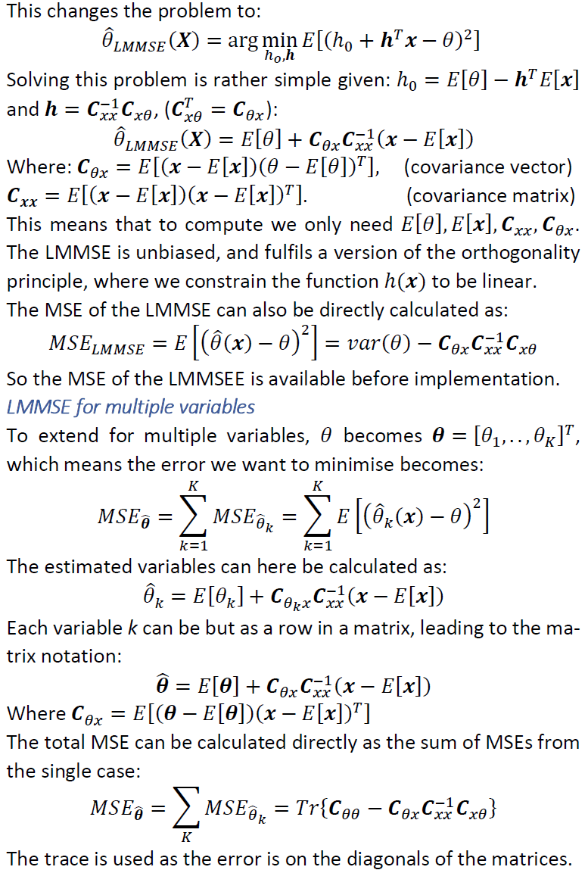
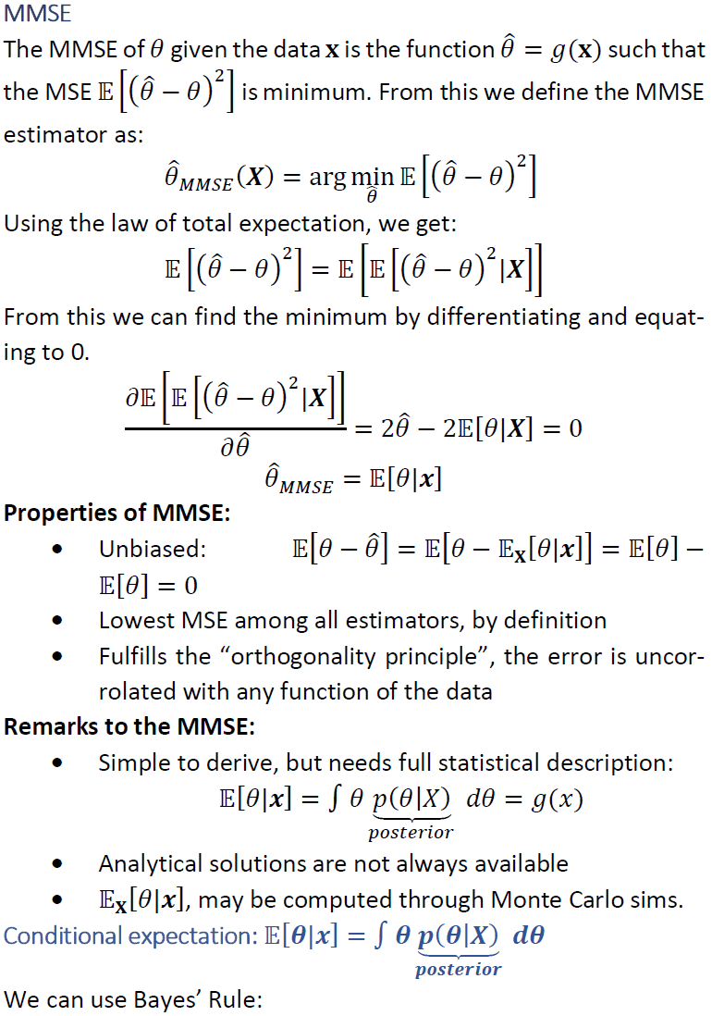
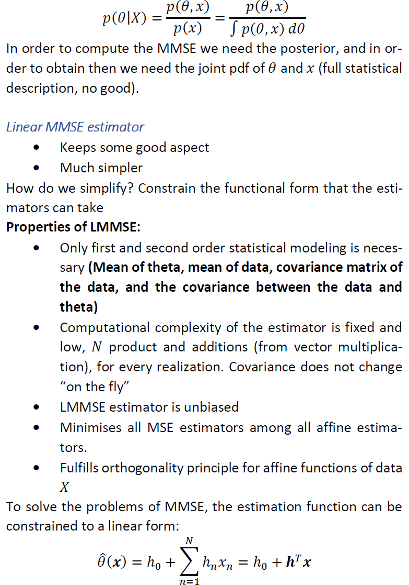
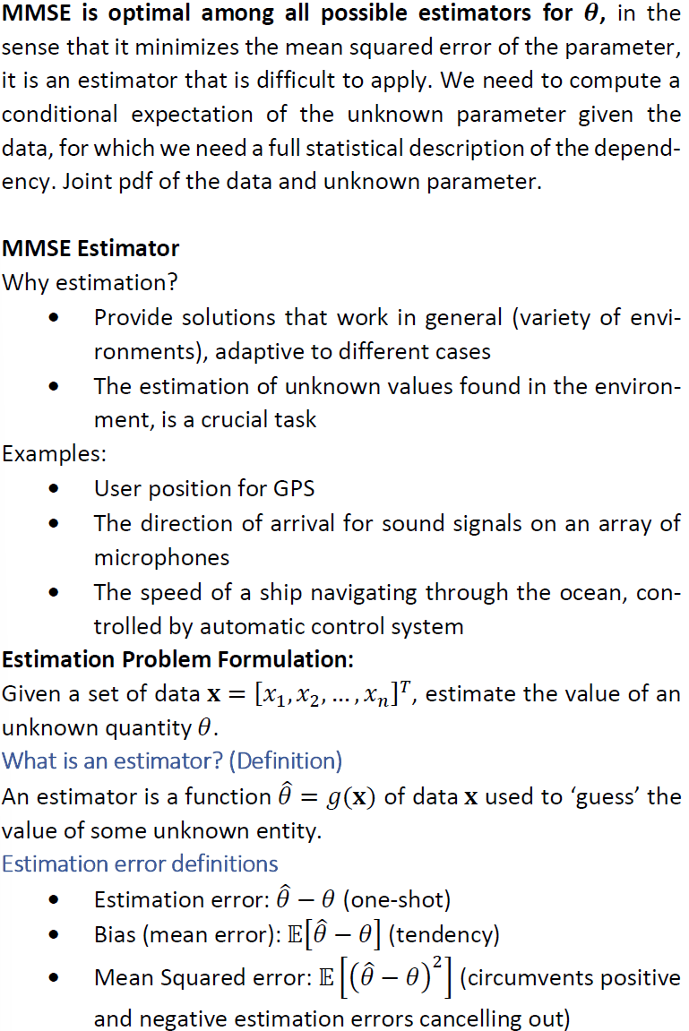

8. Kalman Filtering (scalar and vector versions)
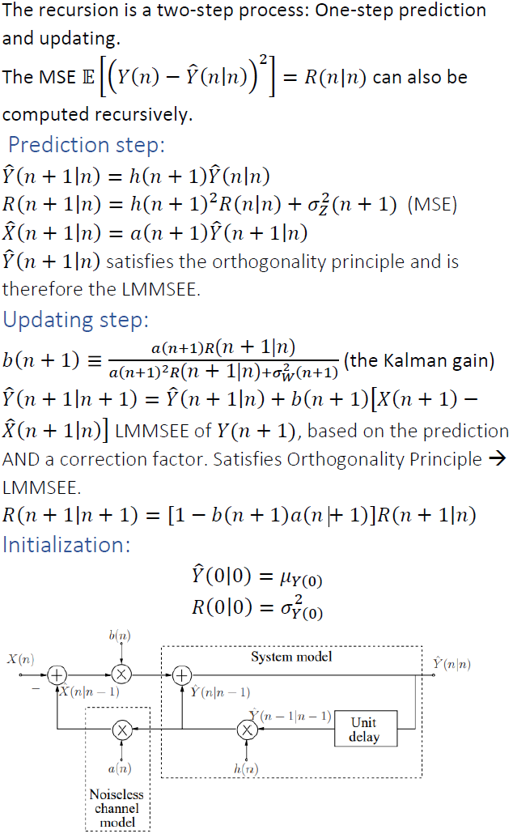
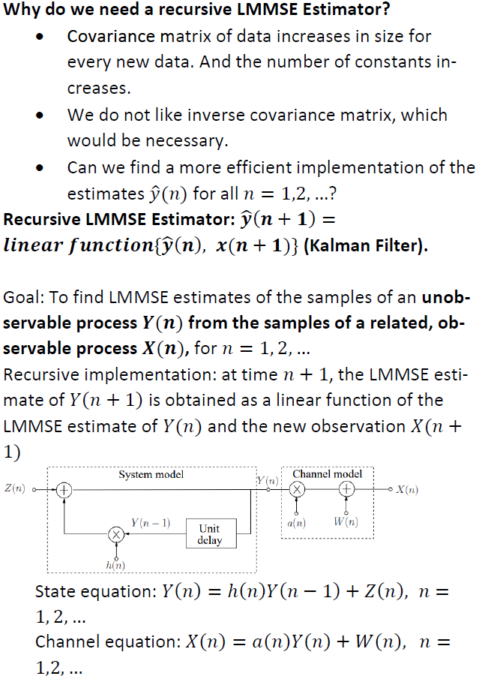
$←$Block Diagram of the scalar Kalman Filter:
System and Channel Model for the scalar Kalman Filter
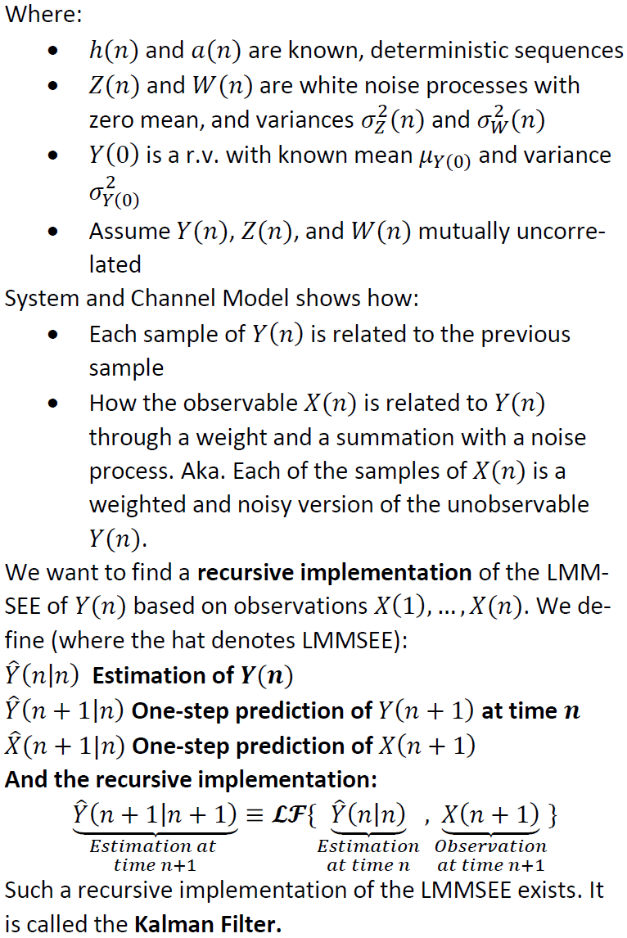
Vector version
When extending to a vector version, the models become:
$$y(n) = H(n)y(n - 1) + z(n), n = 1,2, … \\ x(n) = A(n)y(n) + w(n), n = 1,2, …$$
𝑯(𝑛) and 𝑨(𝑛) are now known matrices describing the relation between previous estimates and new. 𝒛(𝑛) and 𝒘(𝑛) is now vectors of noise. The steps of the Kalman filter changes to:
Prediction Step:
$$\hat{y}(n|n - 1) = H(n)\hat{y}(n - 1|n - 1) \\ \hat{x}(n|n - 1) = A(n)\hat{y}(n|n - 1) \\ R(n|n - 1) = H\left(n\right)R\left(n - 1 | n - 1\right)H{\left(n\right)}^{T} + Q_{z}(n)$$
Updating Step:
$$\hat{y}(n|n) = \hat{y}(n|n - 1) + B(n)(x(n) - \hat{x}(n|n - 1)) \\ R(n|n) = (I - B(n)A(n))R(n|n - 1) \\ B(n) = R\left(n | n - 1\right)A{\left(n\right)}^{T}(A\left(n\right)R\left(n | n - 1\right)A{\left(n\right)}^{T}+ Q_{w}(n))-1$$
Initialization:
$$y\left(0\right) = μ_{y}(0) \\ R(0|0) = cov(y(0))$$

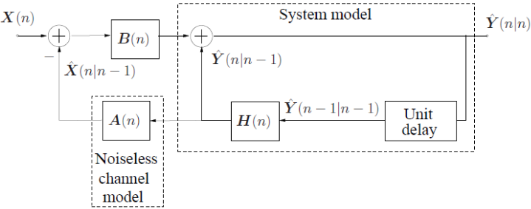
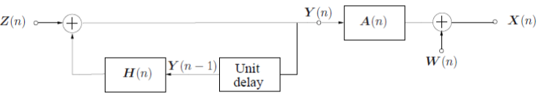
Application:
sensor fusion
$↑$Block Diagram of the vector Kalman Filter
$↑$System and Channel Model for the vector Kalman Filter

9. One-step linear predictor

The one-step linear predictor is a method for predicting the next value in a time series based on the linear combination of previous values. It is commonly used in signal processing, such as speech analysis or AR (autoregressive) modeling.
Concept
The idea is to predict x[n], the current sample, using a weighted sum of its p past samples:
$$\hat{x}\left[n\right]=-\sum_{k=1}^{p}{a_{k}}⋅x\left[n-k\right]$$
$\hat{x}\left[n\right]$: the predicted value.
$x\left[n-k\right]$: the previous samples (past observations).
$a_{k}$​: the predictor coefficients, which determine how much weight to assign to each previous sample.
The error between the actual and predicted value is the prediction error:
$$e\left[n\right]=x\left[n\right]-\hat{x}\left[n\right]$$
Steps to Derive the One-Step Linear Predictor
1. Model the Signal as an AR Process:
Assume the signal x[n] is generated as:
$$x\left[n\right]=-\sum_{k=1}^{p}{a_{k}}⋅x\left[n-k\right]+ e\left[n\right]$$
$a_{k}$​: predictor coefficients to be determined.
$e\left[n\right]$: prediction error (noise).
2. Formulate the Prediction:
Use the past p samples to predict the current sample:
$$\hat{x}\left[n\right]=-\sum_{k=1}^{p}{a_{k}}⋅x\left[n-k\right]$$
The goal is to find $a_{k}$​ that minimizes the error $e\left[n\right]=x\left[n\right]-\hat{x}\left[n\right]$

3. Minimize the Mean Squared Error (MSE):
Apply the principle of least squares:
$$Minimize E\left[e{\left[n\right]}^{2}\right]=$$
$$E\left.\left[{\left.\left(x\left[n\right]+ \sum_{k=1}^{p}{a_{k}}⋅x\left[n-k\right]\right.\right)}^{2}\right.\right]$$
This ensures the best-fit predictor coefficients.
4. Solve for Coefficients $a_{k}$:
- Use the Yule-Walker equations to relate $a_{k}$​ to the autocorrelation $r\left(m\right)$ of $x\left[n\right]$.
- Efficiently compute $a_{k}$​ using the Levinson-Durbin algorithm, avoiding matrix inversion.
5. Predict the Signal:
Substitute $a_{k}$ and past samples into the predictor formula:
$$\hat{x}\left[n\right]=-\sum_{k=1}^{p}{a_{k}}⋅x\left[n-k\right]$$
The result is the one-step prediction of $x\left[n\right].$
Applications
- Speech Processing: Predictive coding for compression (e.g., LPC in audio codecs).
- Error Prediction: Useful in noise reduction and signal denoising.
- AR Models: Fundamental for spectral estimation and time-series analysis.
The one-step linear predictor is an essential tool in AR-based systems, offering both predictive capability and efficient error minimization.
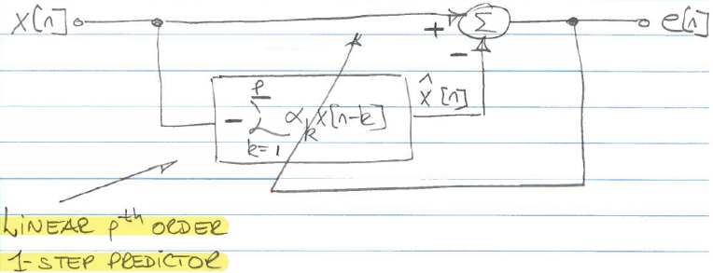

10. The Levinson-Durbin algorithm

The Levinson-Durbin algorithm is an efficient method for solving the Yule-Walker equations used in linear prediction analysis, especially in autoregressive (AR) modeling. Instead of performing expensive matrix inversion, it recursively computes the predictor coefficients for increasing model orders.
Key Steps of the Levinson-Durbin Algorithm
1. Initialization:
- Start with the autocorrelation $r\left(m\right)$ of the signal.
- Set the initial prediction error: $E_{0}=r\left(0\right)$

2. Iterative Computation for Each Order m (from 1 to p):
- Calculate Reflection Coefficient $k_{m}$​:
Use past coefficients and autocorrelation:
$E_{0}=r\left(0\right)$ Initial prediction error
for $m=1$ to $p$
$k_{m}=-\frac{r\left(m\right)+\sum_{k=1}^{m-1}{a_{m-1,k}}⋅r\left(m-k\right)}{E_{m-1}}$ Reflection Coefficient
$a_{m,m}=k_{m}$ Update Predictor Coefficients
for $k=1$ to $m-1$
$a_{m,k}=a_{m-1,k}+k_{m}⋅a_{m-1,m-k}$ Update Predictor Coefficients
end
$E_{m}=E_{m-1}⋅(1-k_{m}^{2})$ Update the Prediction Error
end
$$k_{m}=-\frac{r\left(m\right)+\sum_{k=1}^{m-1}{a_{m-1,k}}⋅r\left(m-k\right)}{E_{m-1}}​$$
$k_{m}$: a "dummy variable" that measures the contribution of the new coefficient.
- Update Predictor Coefficients:
$$a_{m,m}=k_{m}$$

For $k=1$ to $m-1$:
$$a_{m,k}=a_{m-1,k}+k_{m}⋅a_{m-1,m-k}$$
- Update the Prediction Error:
$$E_{m}=E_{m-1}⋅\left(1-k_{m}^{2}\right)$$

3. Repeat Until Desired Order p is Reached:
Continue the recursion until all predictor coefficients $a_{p,k}$ are computed for the p-th order model.
Result
- The final coefficients $a_{p,k}$​ for $k=1,2,…p$ are the Linear Prediction Coefficients (LPC) for the p-th order AR model.
- All lower-order LPCs (for 1 to $p-1$) are also computed during the process.

Advantages
- Efficient (computational cost is $O\left(p^{2}\right)$ compared to $O\left(p^{3}\right)$ for matrix inversion).
- Recursive computation avoids recalculating lower-order models from scratch.
The Levinson-Durbin algorithm is widely used in speech processing, signal prediction, and AR modeling due to its computational efficiency and numerical stability.

11. AR-filter design by modelling

Autoregressive (AR) filter design involves modeling a signal as the output of a linear system driven by white noise. The AR filter parameters are derived from the signal's statistical properties, such as autocorrelation, and are commonly used in signal processing, speech processing, and spectral analysis.
Key Steps for AR-Filter Design by Modeling
1. Model Assumption:
Assume the signal x[n] can be represented as an AR process:
$$x\left[n\right]= \sum_{k=1}^{p}{a_{k}x\left[n-k\right]+e\left[n\right]}$$
$a_{k}$​: AR coefficients (filter parameters)
$p$: Order of the AR model
$e\left[n\right]$: White noise (residual/error)
2. Autocorrelation-Based Estimation:
Compute the autocorrelation sequence $r\left(m\right)$ of the signal, which captures its statistical dependence.
Yule-Walker eq.: $Ra=r$
$R$: Toeplitz autocorrelation matrix.
$a$: AR coefficient vector. $r$: Autocorrelation vector of lagged terms.
3. Solve Yule-Walker Equations:
Use the autocorrelation function to
solve the Yule-Walker equations:
$$r\left(m\right)=-\sum_{k=1}^{p}{a_{k}r\left(m-k\right)}, m=1,2,…p$$
These equations establish a relationship between the AR coefficients and the autocorrelation values.
4. Levinson-Durbin Algorithm (Efficient Computation):
Use the Levinson-Durbin algorithm to recursively calculate the AR coefficients $a_{k}$​ without directly solving the equations.
5. Filter Construction:
Construct the AR filter using the derived coefficients $a_{k}$:
$$H\left(z\right)=\frac{1}{1+\sum_{k=1}^{p}{a_{k}}z^{-k}}$$
$H\left(z\right)$: the transfer function of the AR filter.
6. Stability Check:
Ensure the AR filter is stable by verifying that all poles lie within the unit circle in the z-plane.
7. Signal Modeling/Filtering:
Use the designed AR filter to:
- Generate synthetic signals by driving the filter with white noise.
- Analyze the signal's power spectrum (via the AR model).
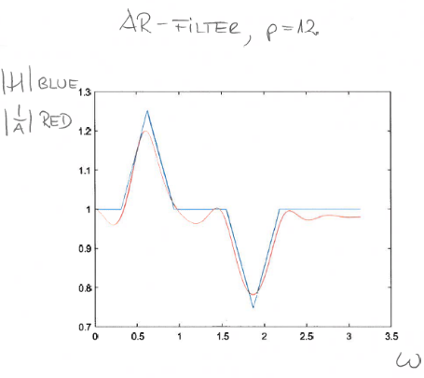
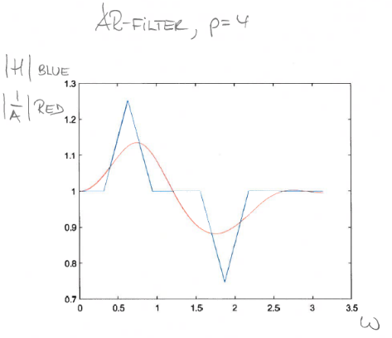
- Predict or smooth the signal by applying the filter.
Applications
- Speech Processing: AR filters model vocal tract resonances.
- Spectral Estimation: AR modeling helps estimate the power spectrum of a signal.
- Signal Prediction: AR filters predict future values in time-series data.
By leveraging AR-filter design, signals can be effectively modeled, analyzed, and processed with high accuracy and computational efficiency.
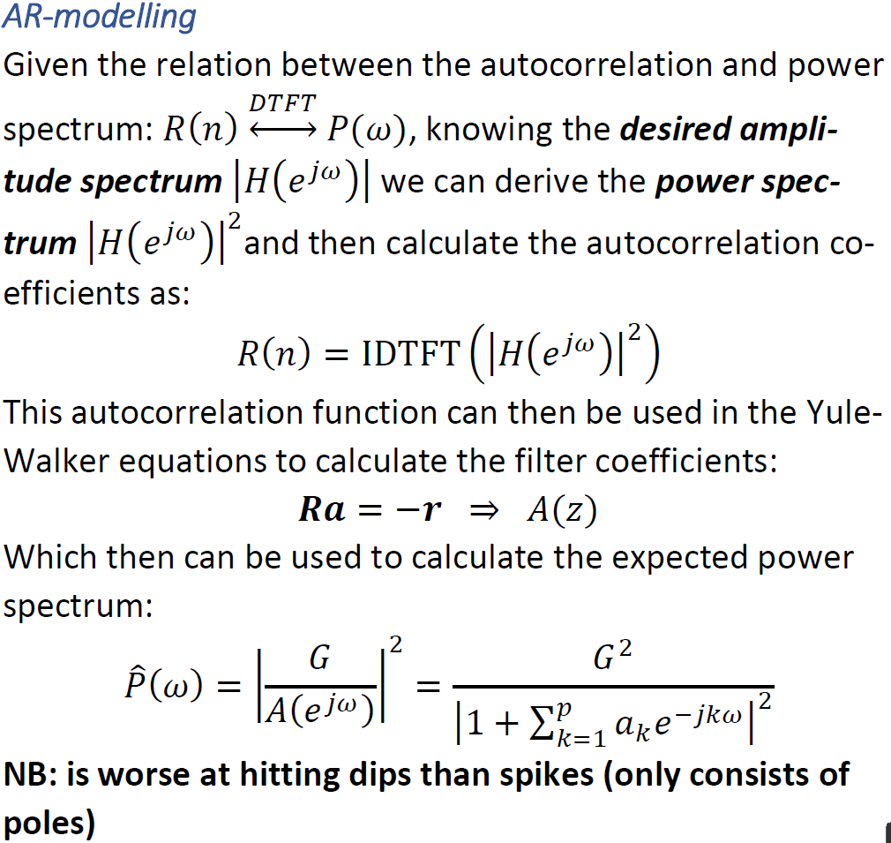

12. The Lattice FIR filter
Core Concept:
The Lattice FIR filter uses a recursive structure to compute forward and backward prediction errors at each stage m, minimizing the residual error.
Equations for Writing:
- Forward Prediction Error: $e^{(m)}\left[n\right]=e^{(m-1)}\left[n\right]-k_{m}{\tilde{e}}^{(m-1)}\left[n-1\right].$
- Backward Prediction Error: ${\tilde{e}}^{(m)}\left[n\right]={\tilde{e}}^{(m-1)}\left[n-1\right]-k_{m}e^{(m-1)}\left[n\right]$.
- Final forward error gives the filter output: $y\left[n\right]=e^{(m)}[n]$.
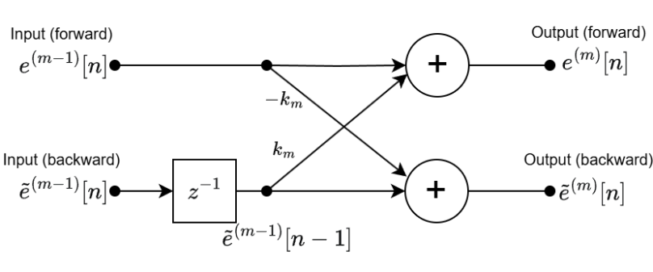
This set of differences equations expresses the m-th order forward and backward prediction errors can be drawn as a Cascade of m Stages (one iteration of the Levinson-Durbin algorithm)
- Horizontal Arrows: Represent the forward and backward error path.
- Diagonal Arrows: Scale the forward and backward paths by the Reflection Coefficient $k_{m}$​.
- Delay Block ($z^{-1}$): Indicate one-sample delay for the backward error.
- At each stage, the forward error $e^{(m-1)}\left[n\right]$ is updated using the previous stage's forward and backward errors, scaled $k_{m}$​ (Reflection Coefficient).
Figure 1: Cascade of m stages
- The cascade structure allows us to compute filter
coefficients recursively, ensuring efficiency and stability.
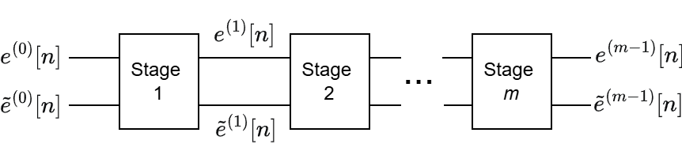
In conclusion we can now state that instead of $A^{(m)}(z)$ being an ordinary tapped-delay-line FIR-filter it can be implemented as a cascade of m sections of the structure figure 1 – This is known as the Lattice Filter. Note: For $m=0$, there’s no prediction, so the error is directly the input signal: $e^{(0)}\left[n\right]=: {\tilde{e}}^{(0)}\left[n\right]=x[n]$

FIR coefficients
The coefficients are calculated from the residual signals(error), and for order m becomes:
$$k_{m}=-\frac{\sum_{n=0}^{N=1}{(e^{\left(m-1\right)}\left[n\right]⋅{\tilde{e}}^{(m-1)}\left[n-1\right])}}{\sum_{n=0}^{N=1}{{\left({\tilde{e}}^{\left(m-1\right)}\left[n\right]\right)}^{2}}}$$
NB: Should be numerical smaller than zero.
NOTE:
- 𝒊th filter coefficient is calculated based on residual signals from the ${\left(i - 1\right)}^{st}$ lattice stage!
- The forward and backward Residual variances are identical for order 𝒎.
- Compared to FIR implementation of LPC, we do not use the columns from the Levinson-Durbin algorithm, but the diagonal ($k_{m}$) ensuring values between −𝟏 and 𝟏
- This is good for fixed-point calculations (proof omitted)

